- The number of employees at B00000005
  - Query:
SELECT COUNT(employeeId)
FROM BranchEmployee
WHERE branch# = ‘B00000005’;
  - Result: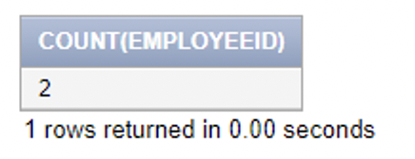

- The total number of employees in all areas for the bank
  - Query:
SELECT COUNT(DISTINCT BranchEmployee.employeeId), COUNT(DISTINCT BankEmployee.employeeId)
FROM BranchEmployee, BankEmployee;
  - Result:

- How many Customers have a loan?
  - Query:
SELECT COUNT(type)
FROM Account
WHERE type = ‘Mortgage’
OR type = ‘Car’
OR type = ‘HELoC’;
  - Result: 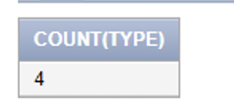

- Which Customers have a loan over $100,000?
  - Query:
SELECT customer#
From CustomerAccount
WHERE CustomerAccount.account# IN (
SELECT account#
FROM Account
WHERE (Account.type = ‘Mortgage’
OR Account.type = ‘Car’
OR Account.type = ‘HELoC’)
AND Account.balance > 100000
);
  - Result: 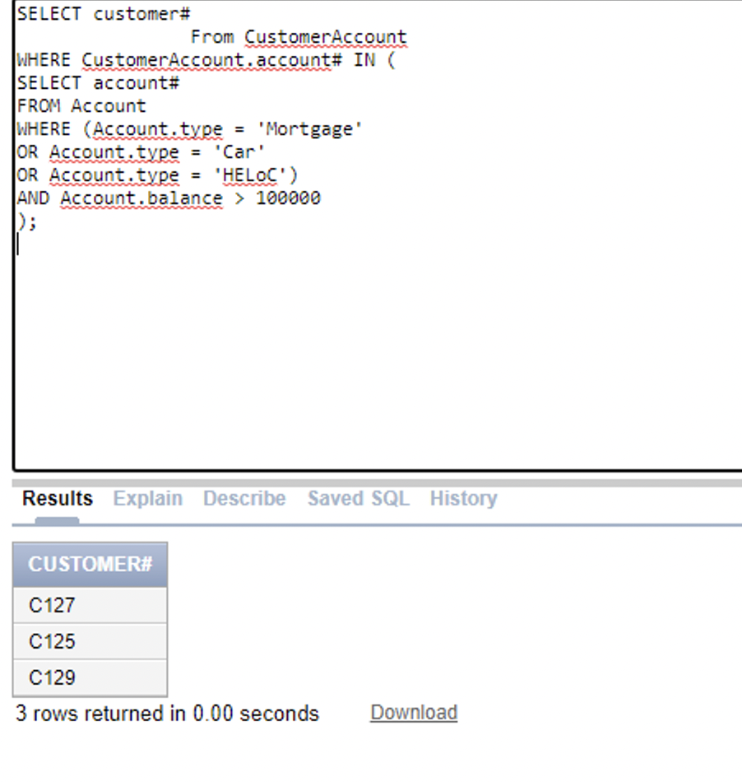

- Which branches are not in the city of Provo?
  - Query:
SELECT branch#
FROM Branch
WHERE Branch.city <> ‘Provo’;
  - Result: 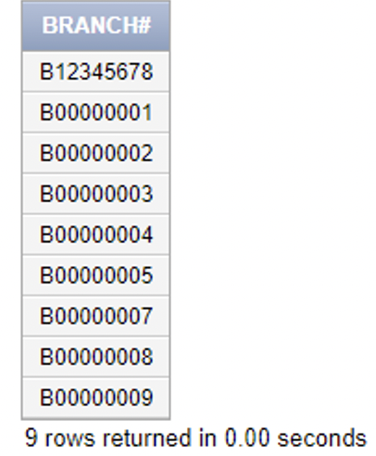

- Get names of people with a loan over $100,000?
  - Query:
SELECT name
FROM Customer
WHERE Customer.customer# IN (
SELECT customer#
From CustomerAccount
WHERE CustomerAccount.account# IN (
SELECT account#
FROM Account
WHERE (Account.type = 'Mortgage'
OR Account.type = 'Car'
OR Account.type = 'HELoC')
AND Account.balance > 100000
)
)
  - Result: 